Ansible Tasks-04
- Create ansible playbook to create ansible vault.
- Write a ansible playbook to install apache in linux and ubuntu machine by using when condition.
- Create ansible playbook using roles to configure LAMP stack
- Setup ansible AWX and explore the options.

Task 1 — Create and use Ansible Vault
Ansible Vault encrypts sensitive information such as passwords, tokens, and database credentials. It is managed using ansible-vault commands rather than a normal playbook that creates the encryption itself.
Since you already ran ansible-vault rekey vault.yml, let's validate your existing vault first.
Step 1: Locate your existing vault
Connect to your Master EC2 instance and run:
cd ~/ansible-lab
pwd
ls -la
find . -name "vault.yml" -type f
This identifies the existing file without creating duplicates.
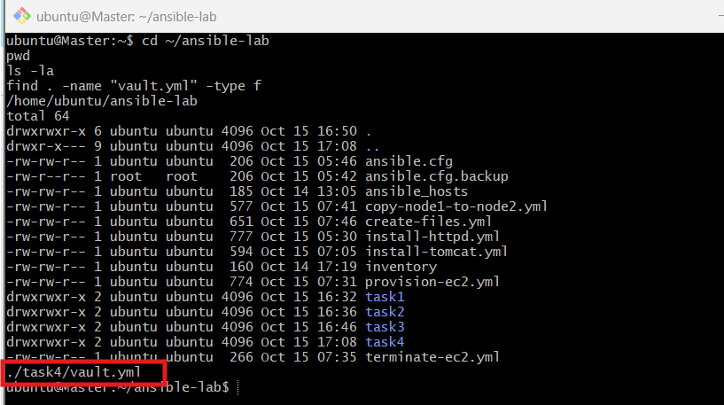
Step 2: Check whether the vault can be decrypted and parsed
If the file is located in ~/ansible-lab/task1/vault.yml, run:
cd ~/ansible-lab/task1
ansible-vault view vault.yml --ask-vault-pass | python3 -c 'import sys,yaml; yaml.safe_load(sys.stdin); print("Vault YAML syntax OK")'
Enter your current vault password when prompted. Do not paste the password or decrypted secrets into the chat.
Expected successful output:
Vault YAML syntax OK
If the command reports a YAML parsing error, the vault may decrypt correctly while its contents still need fixing. If it reports a password or decryption error, we'll troubleshoot that separately.
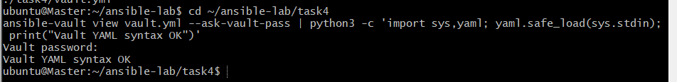
Step 3: Create a playbook that uses Ansible Vault
3.1 Create the playbook
You are already in ~/ansible-lab/task4. Run:
nano vault-demo.yml
Paste this content:

---
- name: Verify Ansible Vault
hosts: localhost
connection: local
gather_facts: false

vars_files:
- vault.yml

tasks:
- name: Verify vault variables are loaded
ansible.builtin.assert:
that:
- app_username is defined
- app_password is defined
- environment_name is defined
success_msg: "All vault variables loaded successfully"
fail_msg: "One or more vault variables are missing"
Save using Ctrl+O, Enter, and exit using Ctrl+X.
Important: This playbook assumes your vault contains a variable named db_user. Let's check that before running it.
3.2 Check the variable names
Run:
ansible-vault view vault.yml --ask-vault-pass
Check whether db_user exists in the decrypted YAML. Don't share any passwords or sensitive values here.
- If db_user exists, continue to Step 3.3.
- If it doesn't exist, tell me the variable names only, without their values, and we'll adjust the playbook.
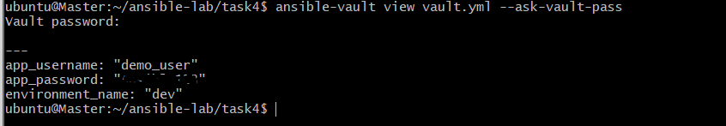
3.3 Run the playbook
If db_user exists, execute:
ansible-playbook vault-demo.yml --ask-vault-pass
Expected result:
TASK [Verify vault variable is loaded]
ok: [localhost] => {
"msg": "Vault variable loaded successfully"
}

PLAY RECAP
localhost : ok=1 changed=0 unreachable=0 failed=0
This verifies that Ansible can decrypt the vault and load the variable.
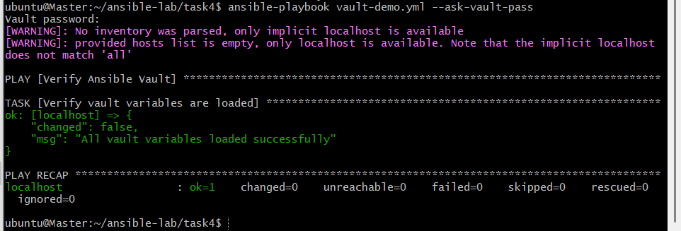

Task 2: Install Apache on Ubuntu and Red Hat Linux using when
Objective: Create a single Ansible playbook that installs Apache on both Ubuntu and Red Hat-based Linux machines using conditional execution.
Step 1: Check your inventory
On your Master EC2 instance, run:
cd ~/ansible-lab
cat inventory
Confirm that your worker1 and worker2 hosts are configured correctly.
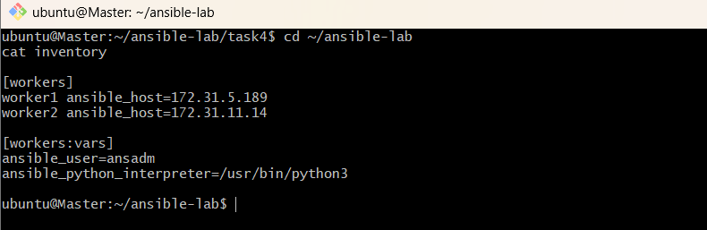
Step 2: Identify the operating systems
Run:
ansible workers -i inventory -m setup -a 'filter=ansible_distribution'
Example output:
worker1 | SUCCESS => {
"ansible_facts": {
"ansible_distribution": "Ubuntu"
}
}
This command identifies the operating system on each worker.
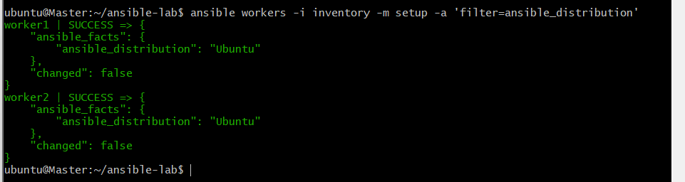
Step 3: Create the playbook
Create a new file:
nano install-apache-when.yml
Paste the following YAML:

---
- name: Install Apache on Ubuntu and Red Hat Linux
hosts: workers
become: true
gather_facts: true

tasks:
- name: Install Apache on Ubuntu or Debian
ansible.builtin.apt:
name: apache2
state: present
update_cache: true
when: ansible_os_family == "Debian"

- name: Install Apache on Red Hat family
ansible.builtin.dnf:
name: httpd
state: present
when: ansible_os_family == "RedHat"

- name: Start and enable Apache on Ubuntu
ansible.builtin.service:
name: apache2
state: started
enabled: true
when: ansible_os_family == "Debian"

- name: Start and enable Apache on Red Hat
ansible.builtin.service:
name: httpd
state: started
enabled: true
when: ansible_os_family == "RedHat"
Save the file using Ctrl+O, press Enter, and exit with Ctrl+X.
Step 4: Execute the playbook
Run:
ansible-playbook -i inventory install-apache-when.yml
The playbook will:
- Install apache2 on Ubuntu and Debian.
- Install httpd on Red Hat-based systems, including Amazon Linux.
- Start the Apache service.
- Enable the service to start automatically after reboot.
If privilege escalation requires a password in your existing setup, use the appropriate Ansible option.
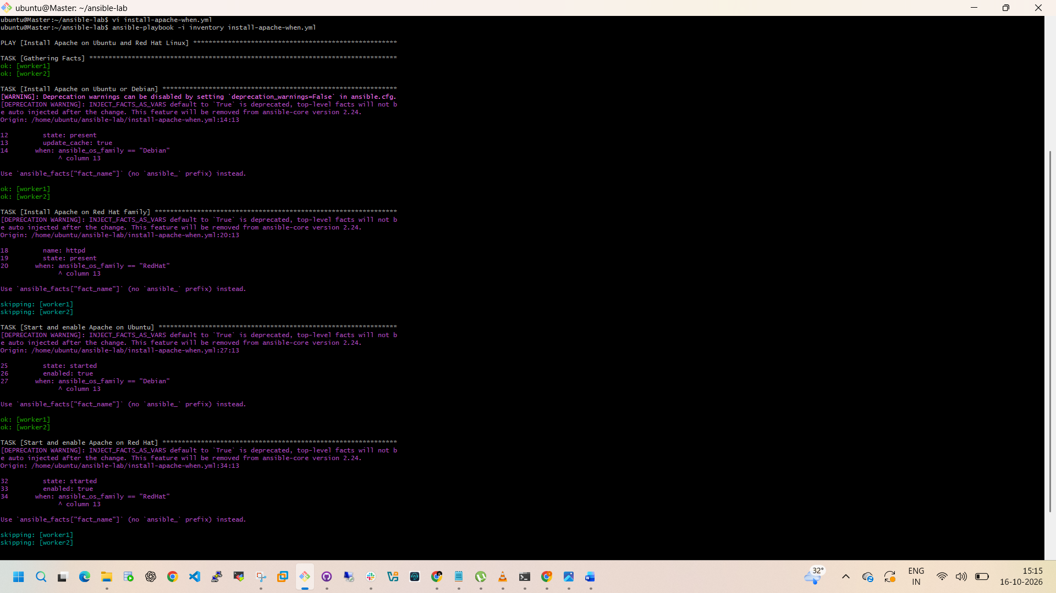
Step 5: Verify Apache is running
Run:
ansible workers -i inventory -b -m shell -a \
'if command -v apache2 >/dev/null 2>&1; then systemctl is-active apache2; elif command -v httpd >/dev/null 2>&1; then systemctl is-active httpd; else echo "Apache package not found"; exit 1; fi'
Expected output:
worker1 | SUCCESS => {
"stdout": "active"
}
worker2 | SUCCESS => {
"stdout": "active"
}
The actual output format may differ slightly.
Task 2 completion criteria: The playbook finishes without failures, and Apache is active on both workers.
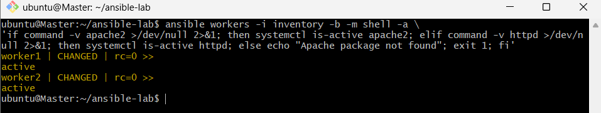
Task 3: Configure a LAMP stack using Ansible roles
LAMP stands for Linux, Apache, MySQL/MariaDB, and PHP.
We will organize the configuration into reusable roles instead of putting every task into one large playbook.
Step 1: Create the project structure
From your Ansible Master:
cd ~/ansible-lab/task3
mkdir -p lamp-project
cd lamp-project
Create the roles directory structure:
mkdir -p roles/apache/tasks
mkdir -p roles/apache/handlers
mkdir -p roles/apache/templates
mkdir -p roles/database/tasks
mkdir -p roles/php/tasks
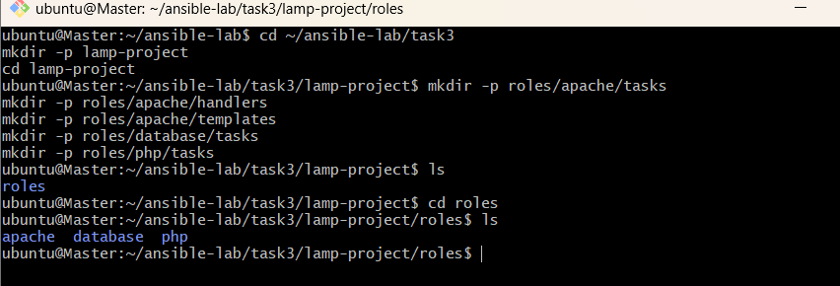
Step 2: Create the Apache role
Create:
nano roles/apache/tasks/main.yml
Add:
---
- name: Install Apache on Debian family
ansible.builtin.apt:
name: apache2
state: present
update_cache: true
when: ansible_os_family == "Debian"

- name: Install Apache on Red Hat family
ansible.builtin.dnf:
name: httpd
state: present
when: ansible_os_family == "RedHat"

- name: Start and enable Apache on Debian family
ansible.builtin.service:
name: apache2
state: started
enabled: true
when: ansible_os_family == "Debian"

- name: Start and enable Apache on Red Hat family
ansible.builtin.service:
name: httpd
state: started
enabled: true
when: ansible_os_family == "RedHat"
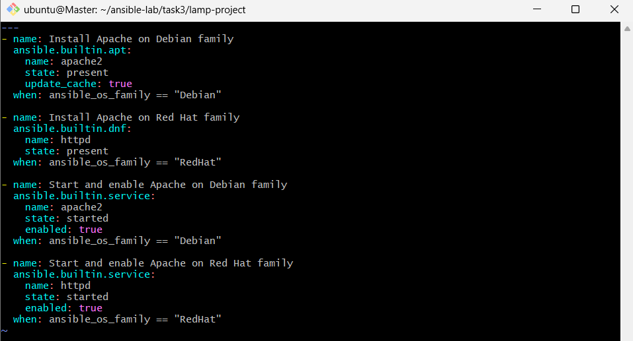
Step 3: Create the database role
Create:
nano roles/database/tasks/main.yml
Add:
---
- name: Install MariaDB on Debian family
ansible.builtin.apt:
name:
- mariadb-server
- python3-pymysql
state: present
update_cache: true
when: ansible_os_family == "Debian"

- name: Install MariaDB on Red Hat family
ansible.builtin.dnf:
name:
- mariadb-server
- python3-PyMySQL
state: present
when: ansible_os_family == "RedHat"

- name: Start and enable MariaDB
ansible.builtin.service:
name: mariadb
state: started
enabled: true
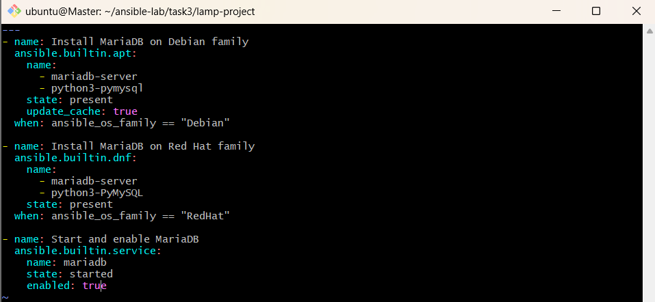
Step 4: Create the PHP role
Create:
nano roles/php/tasks/main.yml
Add:
---
- name: Install PHP on Debian family
ansible.builtin.apt:
name:
- php
- libapache2-mod-php
- php-mysql
state: present
update_cache: true
when: ansible_os_family == "Debian"

- name: Install PHP on Red Hat family
ansible.builtin.dnf:
name:
- php
- php-mysqlnd
state: present
when: ansible_os_family == "RedHat"
Package availability may depend on the Linux distribution and enabled repositories.
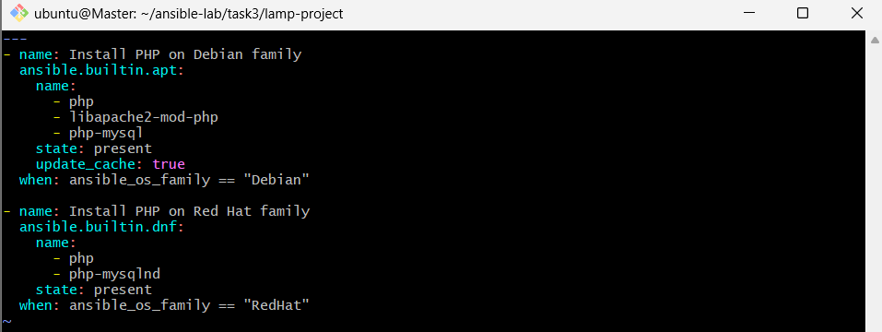
Step 5: Create the main playbook
From ~/ansible-lab/task3/lamp-project, run:
nano site.yml
Add:
---
- name: Configure LAMP Stack
hosts: workers
become: true
gather_facts: true

roles:
- apache
- database
- php
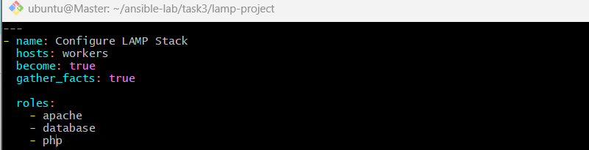
Step 6: Execute and verify
Use your existing inventory:
ansible-playbook -i ../../inventory site.yml
Verify services:
ansible workers -i ../../inventory -b -m shell -a \
'systemctl is-active mariadb; if command -v apache2 >/dev/null 2>&1; then systemctl is-active apache2; else systemctl is-active httpd; fi'
This installs the LAMP components. A production-ready LAMP deployment would also need database hardening, secure credentials, and application-specific PHP configuration.
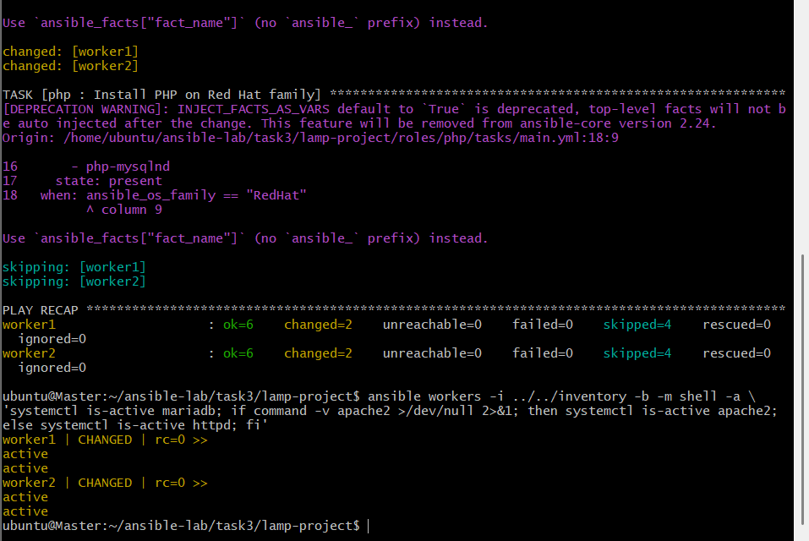

Task 4: Install and explore Ansible AWX
AWX is the open-source web-based automation platform associated with Ansible Automation Controller.
Important: AWX is more resource-intensive than a basic Ansible lab. Your existing Master instance has previously had limited disk space, so check resources before installation. I recommend a separate Ubuntu EC2 instance for AWX rather than installing it on your current Ansible Master.
Step 1: Check the system resources
On the machine you plan to use for AWX, run:
lsb_release -a
free -h
df -h
nproc
Also check whether Docker or a Kubernetes cluster is already installed:
docker --version
kubectl version --client
These commands may report that one or both tools are missing; that is fine at this stage.
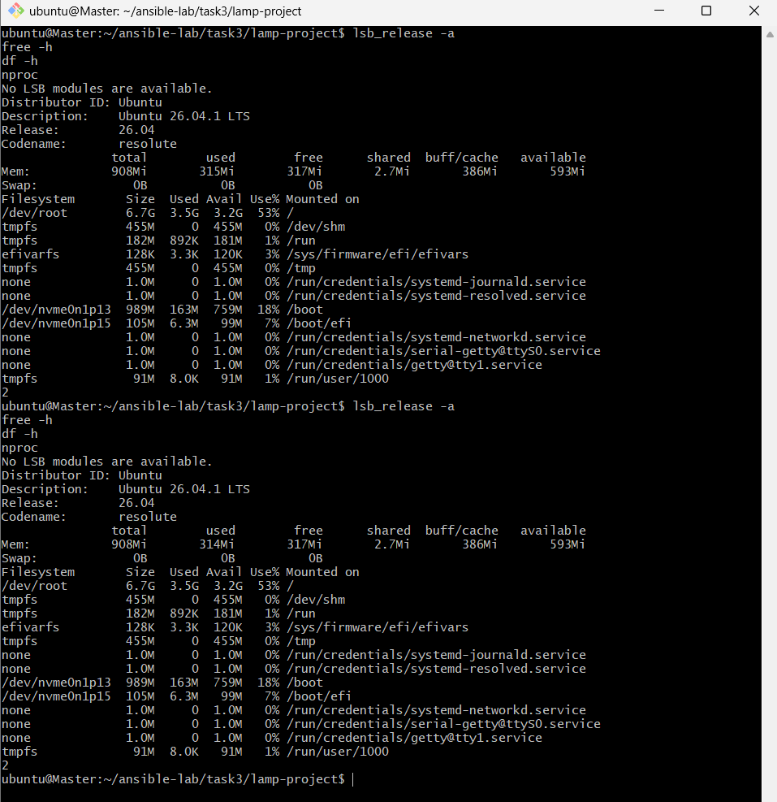
Step 2: Launch the AWX server
In AWS Console, open EC2 → Launch instance and use these settings:
Setting | Value
Name | AWX-Server
AMI | Ubuntu Server 24.04 LTS
Instance type | t3.small
Storage | 30 GB gp3
Security group | SSH (22) from My IP
Key pair | Select your existing key pair
Cost warning: t3.small may incur charges depending on your account's Free Tier offer and remaining credits. A 30 GB disk may also incur charges. Check the AWS billing estimate before launching.
For now, do not open AWX's web port to the public internet.
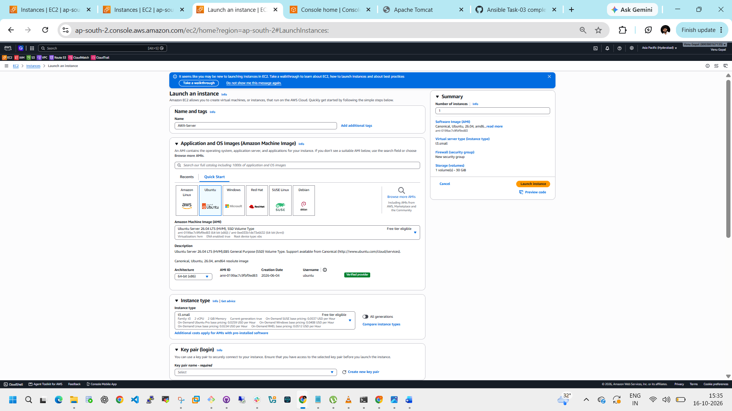
Step 3: Connect and check resources
After launching, connect to the instance:
ssh -i "your-key.pem" ubuntu@YOUR_AWX_PUBLIC_IP
Then run:
free -h
df -h
nproc
lsb_release -a
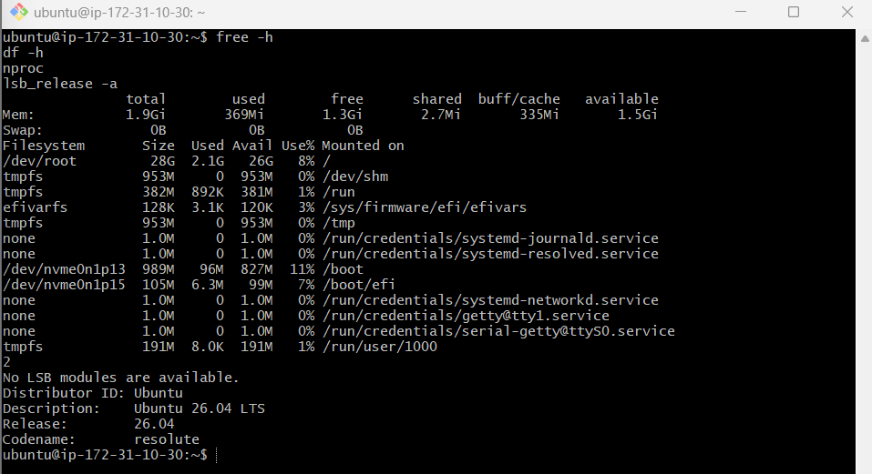
Step 4 — Update Ubuntu
Run these commands on AWX-Server:
sudo apt update
sudo apt upgrade -y
sudo apt install -y curl git wget ca-certificates
Verify the utilities:
git --version
curl –version
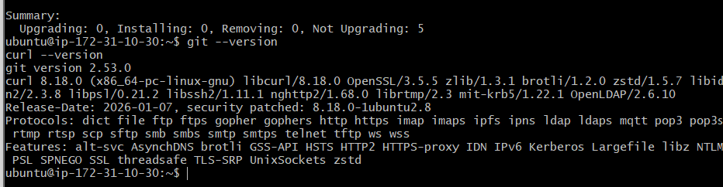
Step 5 — Verify cluster health
Run these commands on your Kubernetes master:
kubectl get nodes
kubectl get pods -A
kubectl get storageclass
Confirm:
- All 3 nodes show Ready.
- System pods are Running or completed successfully.
- Your ebs-sc StorageClass appears, if you plan to use EBS storage for AWX.
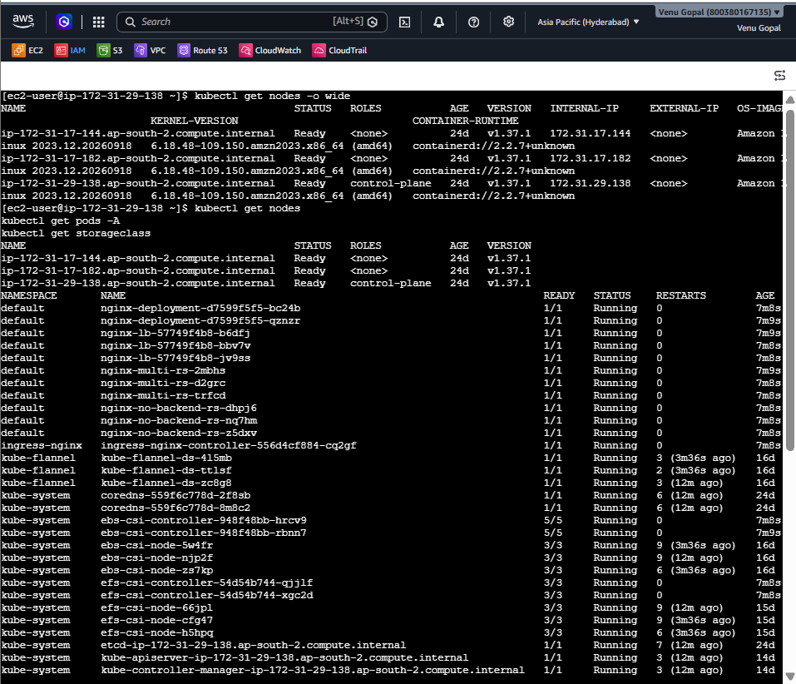
Step 6 — Check available resources
kubectl top nodes
kubectl describe nodes | grep -A5 "Allocated resources"
If kubectl top nodes reports that Metrics API is unavailable, skip that command for now.
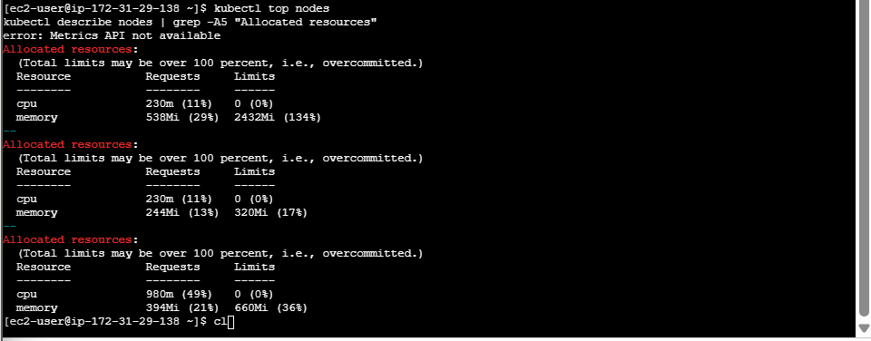

Step 7 — Check node resources
Run these commands on your Kubernetes master:
kubectl describe node ip-172-31-29-138.ap-south-2.compute.internal | grep -A5 "Capacity:"
kubectl describe node ip-172-31-17-144.ap-south-2.compute.internal | grep -A5 "Capacity:"
kubectl describe node ip-172-31-17-182.ap-south-2.compute.internal | grep -A5 "Capacity:"
Then check your existing StorageClasses:
kubectl get storageclass
Your output currently shows only efs-sc, which is fine if we configure AWX to use EFS-backed persistent storage.
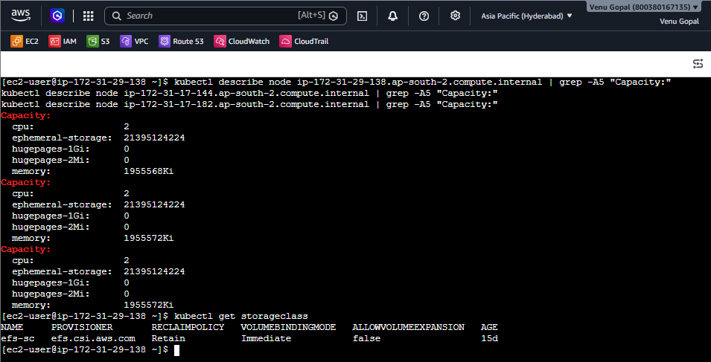
Step 8 — Check resource usage and available disk space
Run these commands on the Kubernetes master:
kubectl describe node ip-172-31-29-138.ap-south-2.compute.internal | grep -A6 "Allocated resources"
kubectl describe node ip-172-31-17-144.ap-south-2.compute.internal | grep -A6 "Allocated resources"
kubectl describe node ip-172-31-17-182.ap-south-2.compute.internal | grep -A6 "Allocated resources"
Check disk space on all three EC2 instances by connecting to each instance and running:
df -h /
free -h
Your existing efs-sc StorageClass is available, so we don't need to create another StorageClass yet.
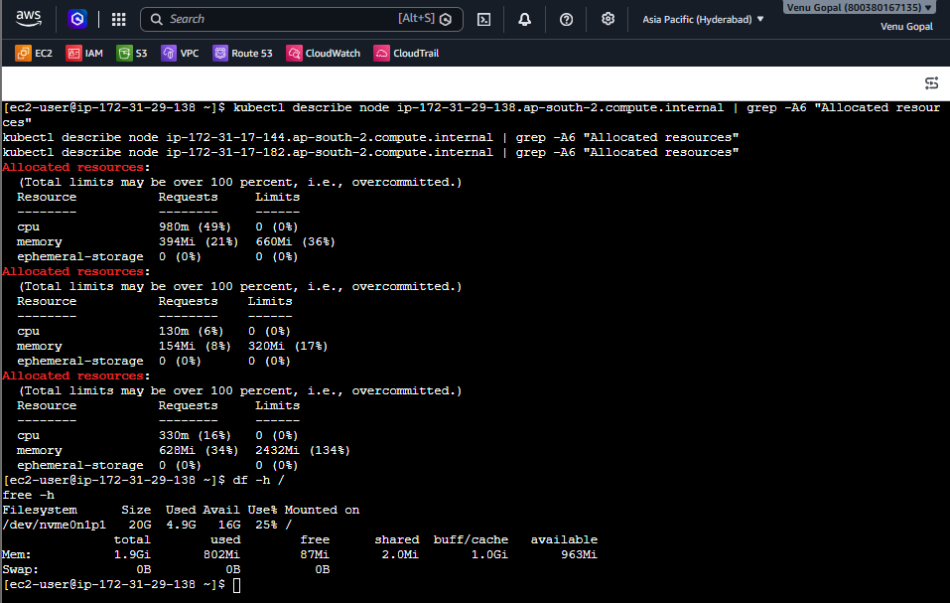
Step 9 — Check worker resources through AWS
- Open the AWS EC2 Console in the Hyderabad region (ap-south-2).
- Select your Worker 1 instance (172.31.17.144).
- Click Connect → EC2 Instance Connect and connect.
- Run:
free -h
df -h /
5. Repeat for Worker 2 (172.31.17.182).
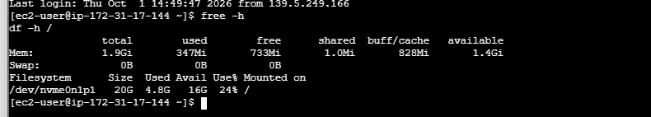
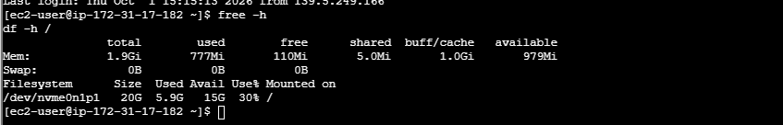

Step 10 — Check Kubernetes cluster version and Helm
Run these commands on the master:
kubectl version
helm version
kubectl get pods -A
If Helm is installed, the version command will return its version. If it isn't installed, you'll see a command-not-found error.
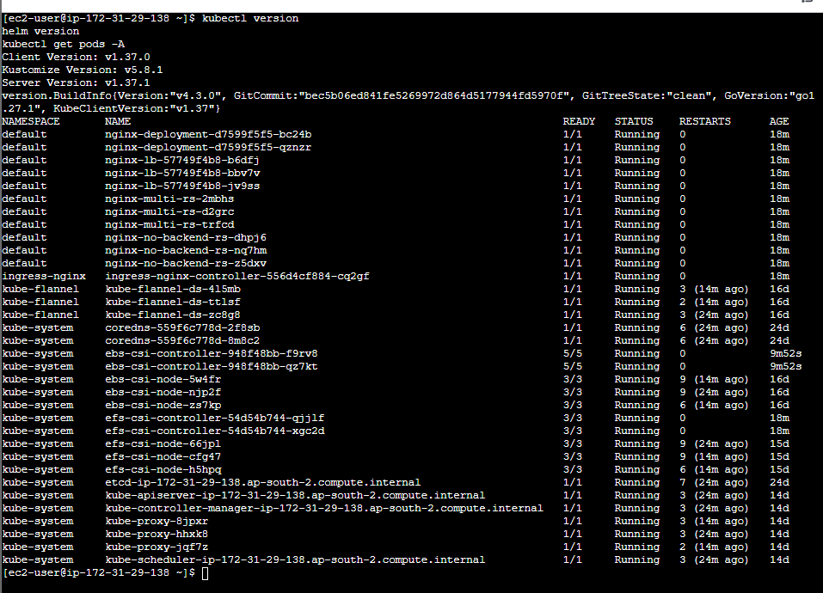
Step 11 — Check AWX Operator requirements
On your Kubernetes master, run:
kubectl get nodes
helm list -A
kubectl get pods -n awx
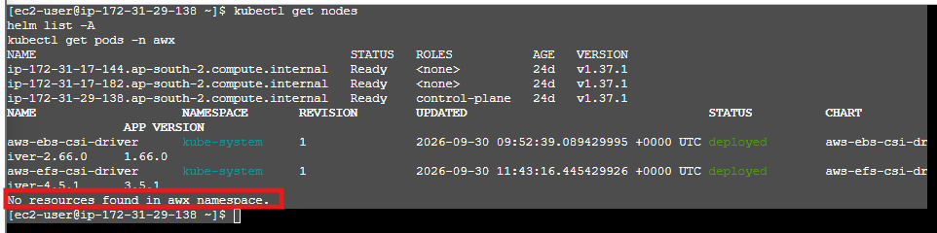
The last command may report that the awx namespace doesn't exist yet; that's fine.
Next, check the official AWX Operator documentation:
AWX Operator — official GitHub repository

Step 12 — Check AWX Operator release
On the Kubernetes master, run:
git ls-remote --tags https://github.com/ansible/awx-operator.git
This lists available operator releases without installing anything. Check that the command completes successfully.
Then run:
kubectl get nodes -o wide
kubectl get pods -A --field-selector=status.phase!=Running
The second command may list completed or pending pods; we'll review the results before proceeding.
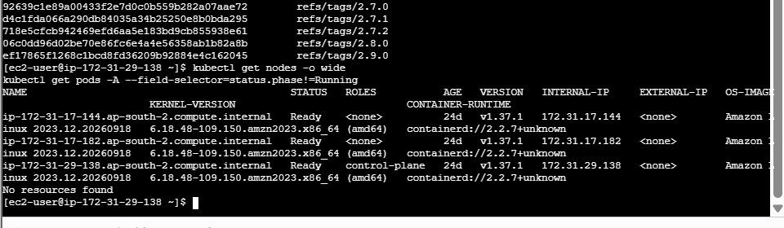
Step 13 — Clone the AWX Operator
For this lab, let's use a specific release rather than the moving master branch. First, clone the repository:
git clone https://github.com/ansible/awx-operator.git
cd awx-operator
List the latest release tags you retrieved:
git tag --sort=-version:refname | head -10
Because your Kubernetes cluster has only about 2 GiB RAM per node, don't install the operator or AWX yet. We should confirm the release's compatibility and resource requirements first.
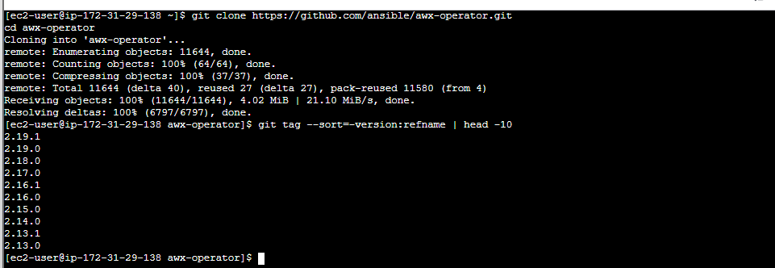
Step 14 — Check the release requirements
Run these commands from your current directory, ~/awx-operator:
git checkout 2.19.1
Then check the release documentation and deployment defaults:
grep -n -i -E 'kubernetes|memory|requirements|postgres' README.md | head -30
Check the default AWX custom resource example:
ls
find . -maxdepth 3 -iname '*awx*.yaml' -o -iname '*awx*.yml'
Don't install the operator yet. Your three nodes each have approximately 2 GiB RAM, and we need to verify the requirements before deploying AWX and its database.
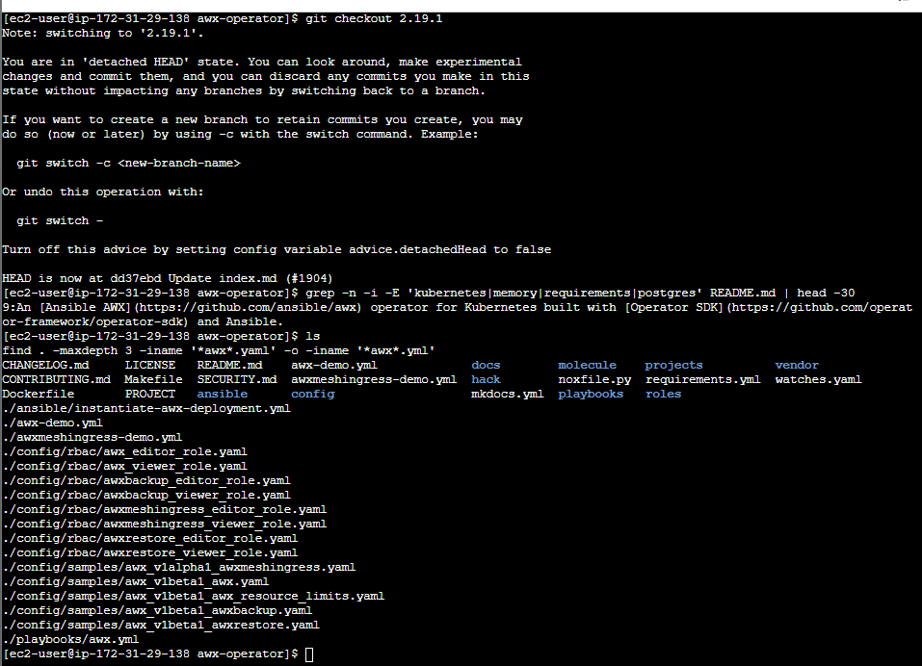
Step 15 — Inspect the AWX resource configuration
Run these commands from ~/awx-operator:
1. View the sample configuration
cat config/samples/awx_v1beta1_awx.yaml
2. View the resource-limit example
cat config/samples/awx_v1beta1_awx_resource_limits.yaml
3. Check the operator's supported Kubernetes API versions
grep -R -n 'kubeVersion\|kubernetesVersion' config/metadata.yaml PROJECT
If the last command returns no matches, that's okay.
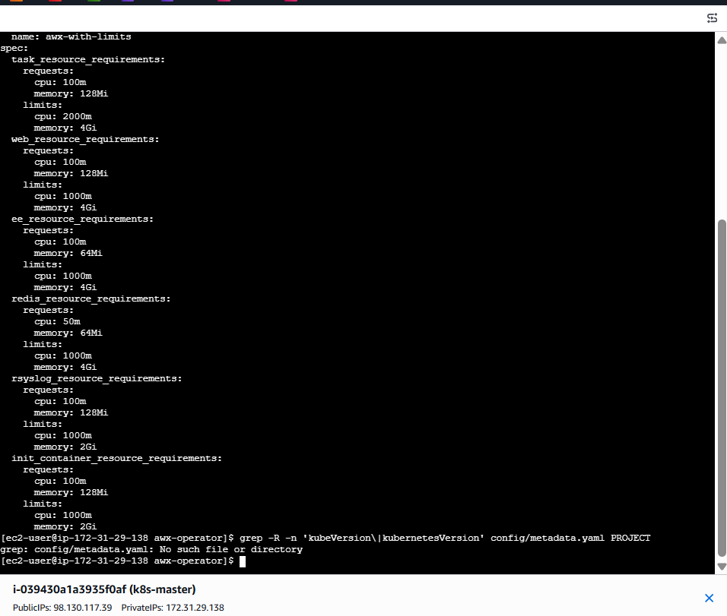
Step 16 — Run this command on the master node:
grep -n -A20 -B5 '^deploy:\|^install:' Makefile
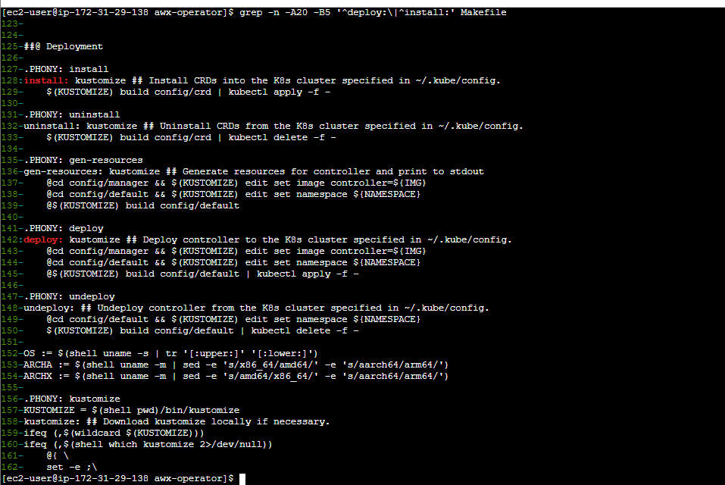
Step 17 — Check prerequisites
Run this on the master node:
cd ~/awx-operator

kubectl get nodes
kubectl get pods -A
make --version
Then check whether Kustomize is already available:
ls -l bin/kustomize
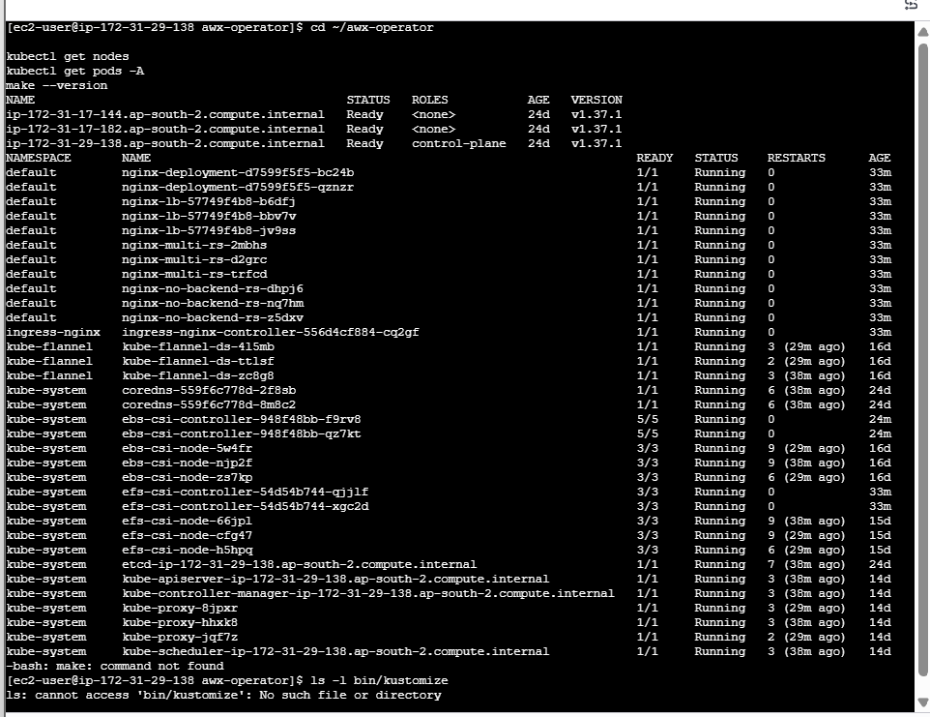
Step 18 — Install Make
Run this on the master node:
sudo dnf install make -y
Verify:
make --version
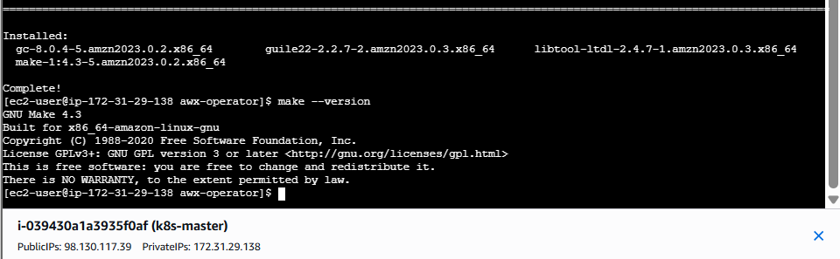
Step 19 — Install Kustomize
Run this command from ~/awx-operator on the master node:
cd ~/awx-operator
make kustomize
After it finishes, verify the installation:
./bin/kustomize version
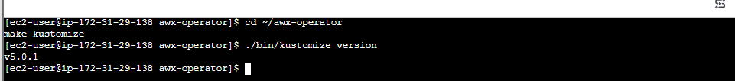
Step 20 — Check the AWX Operator deployment configuration
Before deploying, run:
cd ~/awx-operator
grep -nE '^(IMG|VERSION|NAMESPACE)[[:space:]]*[:?+]?=' Makefile
Then check the operator image configuration:
cat config/manager/kustomization.yaml
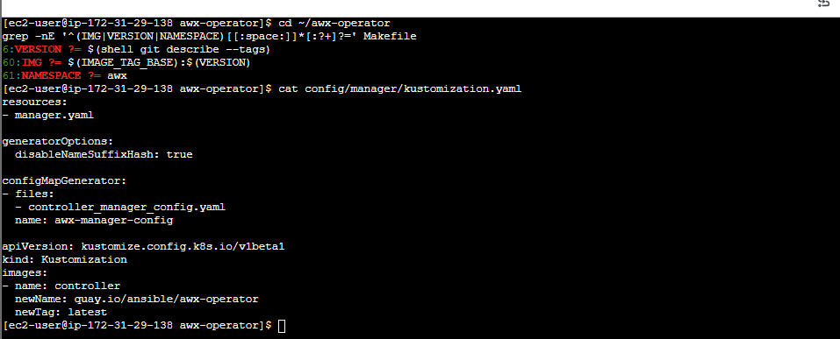
Step 21 — Prepare the AWX Operator image
Run these commands from ~/awx-operator:
cd ~/awx-operator

make deploy IMG=quay.io/ansible/awx-operator:2.19.1
Wait before running this command: your existing Kubernetes cluster has limited RAM, and AWX can consume substantial resources. Deploying now could affect your existing workloads. First, run this read-only check:
free -h
kubectl describe nodes | grep -E 'Name:|Allocatable:|cpu:|memory:'
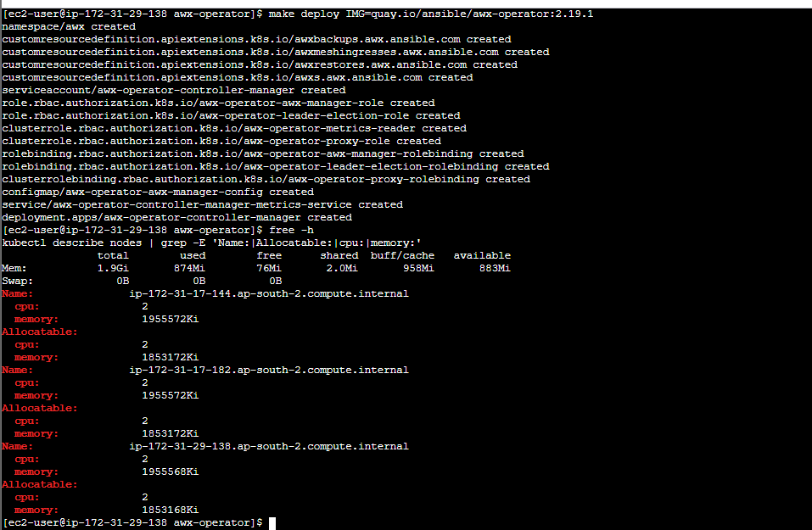
Step 22 — Verify the operator
Run:
kubectl get pods -n awx
kubectl get deployment -n awx
kubectl get events -n awx --sort-by=.lastTimestamp | tail -15
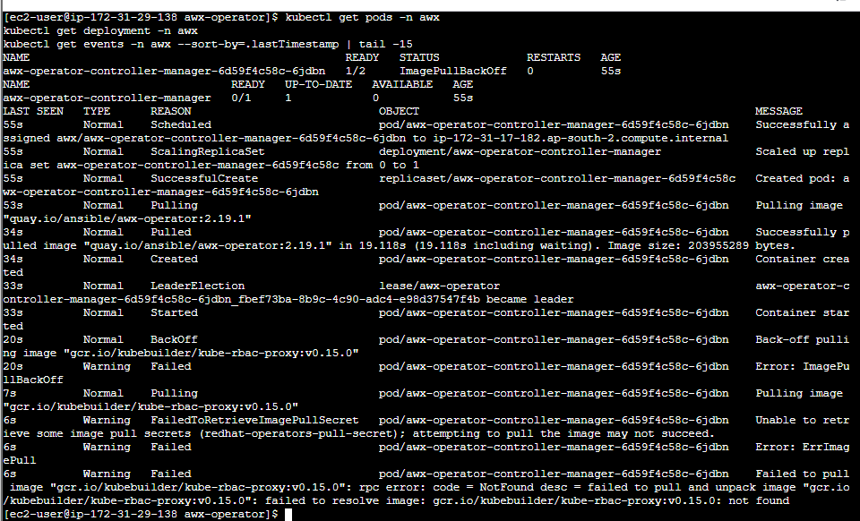

Step 23 — Check the image configuration
Run these commands on the master node:
cd ~/awx-operator

grep -R -n 'kube-rbac-proxy\|redhat-operators-pull-secret' config
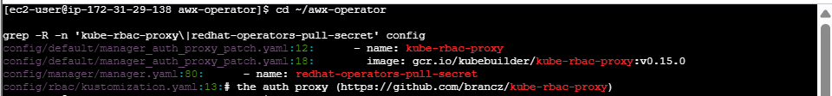
Then run:
kubectl get deployment awx-operator-controller-manager -n awx -o yaml | grep -n -A8 -B8 'kube-r
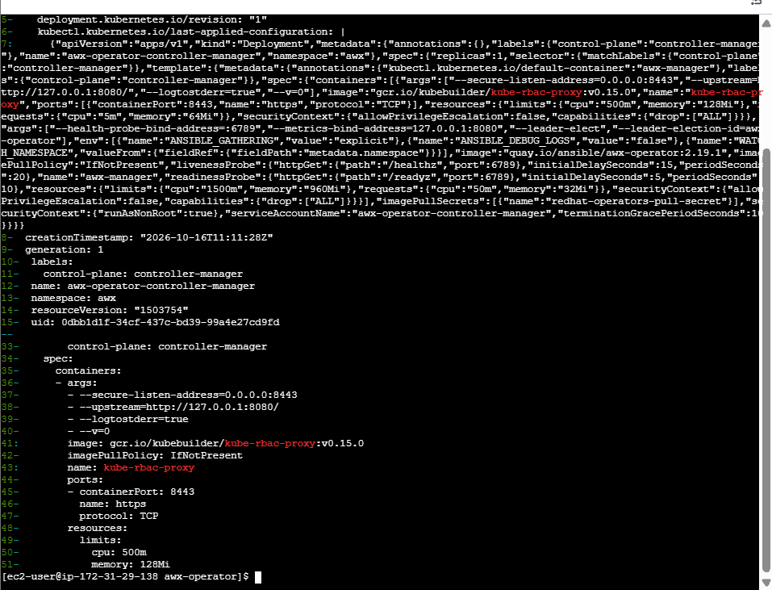
Step 24 — Check an alternative image
Run this command on the master node to test whether the alternative image is available:
sudo crictl pull gcr.io/kubebuilder/kube-rbac-proxy:v0.15.0
Step 25 — Update the proxy image
First, check whether the alternative image exists in the registry:
sudo dnf install -y skopeo
skopeo inspect docker://quay.io/brancz/kube-rbac-proxy:v0.18.1
If the inspection succeeds, run:
cd ~/awx-operator

sed -i 's#gcr.io/kubebuilder/kube-rbac-proxy:v0.15.0#quay.io/brancz/kube-rbac-proxy:v0.18.1#' config/default/manager_auth_proxy_patch.yaml

make deploy IMG=quay.io/ansible/awx-operator:2.19.1
Then check:
kubectl get pods -n awx
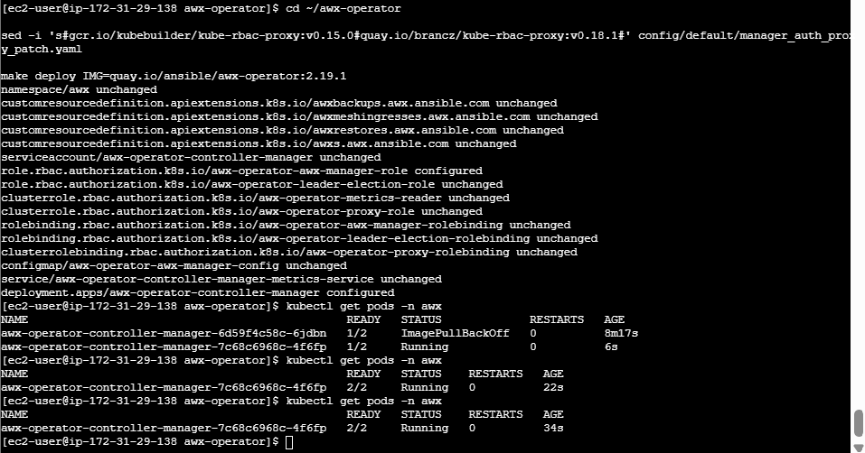

Task 4 — Set up Ansible AWX and explore its options

Objective
Deploy AWX on an existing Kubernetes cluster using the official AWX Operator, access its web dashboard, and explore automation features.
Environment
EC2 Linux · Kubernetes · AWX Operator 2.19.1 · kubectl
Step 1 — Verify the existing Kubernetes cluster
Run these commands on your EC2 machine:
kubectl get nodes
kubectl get namespaces
kubectl get pods -A
Expected: your Kubernetes node should be Ready.
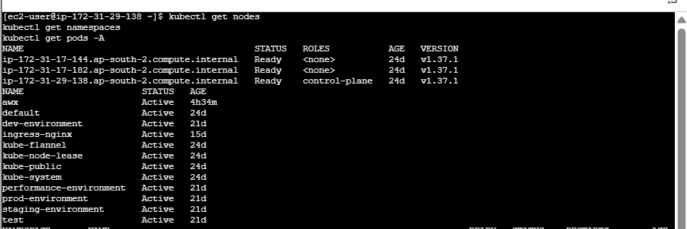
Check whether AWX is already deployed:
kubectl get pods -n awx
kubectl get svc -n awx
kubectl get deployments -A | grep -i awx
If the cluster is healthy, continue. If the awx namespace does not exist, proceed with the installation steps below.
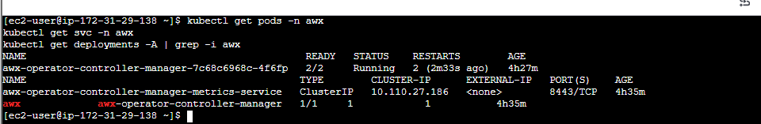
Step 2 — Create the working directory
mkdir -p ~/awx-lab
cd ~/awx-lab
If you already cloned the repository, do not clone it again.
Step 3 — Download the official AWX Operator
For a new installation:
cd ~/awx-lab

git clone --branch 2.19.1 \
https://github.com/ansible/awx-operator.git

cd awx-operator
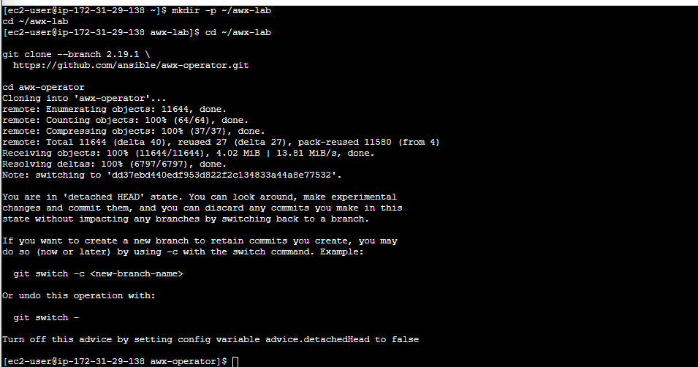
Verify the version and repository:
git describe --tags --always
git status
If ~/awx-lab/awx-operator already exists, enter that directory instead of cloning again.
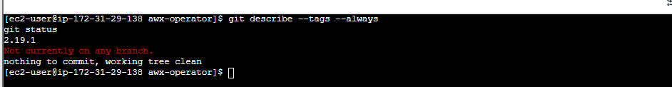
Step 4 — Install the AWX Operator
First, inspect the current installation:
kubectl get pods -A | grep -i awx
kubectl get crd | grep awx
If the operator is not installed, apply its configuration:
cd ~/awx-lab/awx-operator

make deploy IMG=quay.io/ansible/awx-operator:2.19
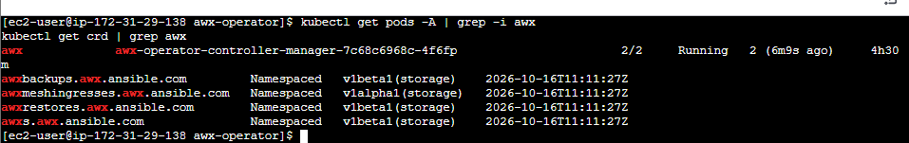
Your earlier terminal output showed a proxy image pull issue. If that error occurs again, inspect the configured image:
grep -n 'kube-rbac-proxy' \
config/default/manager_auth_proxy_patch.yaml

Your earlier documented fix used registry.k8s.io/kubebuilder/kube-rbac-proxy:v0.15.0. Verify that the image exists and is accessible from your cluster before changing the configuration. Then reapply the operator configuration using the deployment method appropriate to your current installation.
Verify the operator:
kubectl get pods -A | grep -i awx
kubectl get deployments -A | grep -i awx
Wait until the operator pod's containers are ready before continuing.
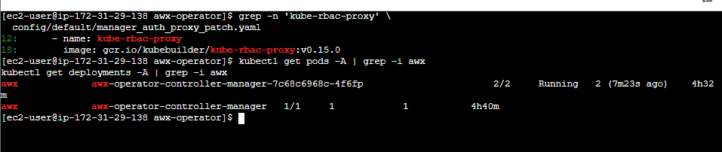
Step 5 — Configure the AWX custom resource
Create a YAML file:
cd ~/awx-lab
nano awx-demo.yaml
Add the following configuration. This is a resource-request example for a small lab, not a guarantee that the full deployment will fit within your machine's capacity.

---
apiVersion: awx.ansible.com/v1beta1
kind: AWX
metadata:
name: awx-demo
namespace: awx
spec:
web_resource_requirements:
requests:
cpu: 50m
memory: 128Mi

task_resource_requirements:
requests:
cpu: 50m
memory: 128Mi

ee_resource_requirements:
requests:
cpu: 50m
memory: 64Mi

postgres_storage_class: standard

postgres_storage_requirements:
requests:
storage: 8Gi

postgres_resource_requirements:
requests:
cpu: 10m
memory: 64Mi
Save in Nano using Ctrl+O, press Enter, then Ctrl+X.
Important: This configuration requests 8 GiB of PostgreSQL storage. Check the available disk space and storage provisioner first. Very low CPU and memory requests do not prevent pods from consuming more resources.
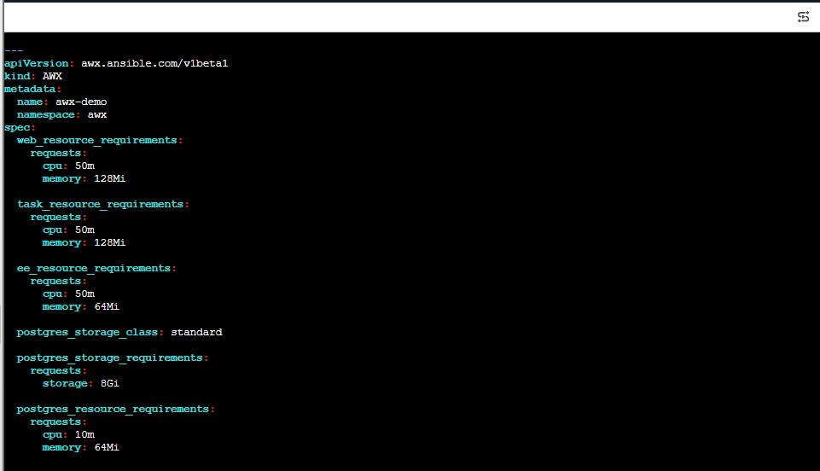
Step 6 — Validate and deploy AWX
Check that the namespace exists:
kubectl get namespace awx
If it does not exist, create it:
kubectl create namespace awx
Confirm that the AWX custom resource definition exists:
kubectl get crd awxs.awx.ansible.com
Validate the YAML against the Kubernetes API:
kubectl apply --dry-run=server -f ~/awx-lab/awx-demo.yaml
If validation succeeds, deploy:
kubectl apply -f ~/awx-lab/awx-demo.yaml
Verify:
kubectl get awx -n awx
kubectl get pods -n awx -w
Press Ctrl+C to stop watching after checking the pod states. This does not stop the workloads.
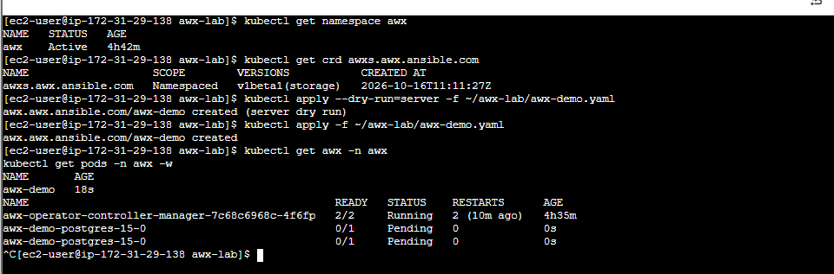
Step 7: Verify AWX status — Completed ✅
Your previous output confirms:
Component | Status
PostgreSQL | 1/1 Running
AWX Task | 4/4 Running
AWX Web | 3/3 Running
Migration Job | Complete
AWX Service | Available on port 80
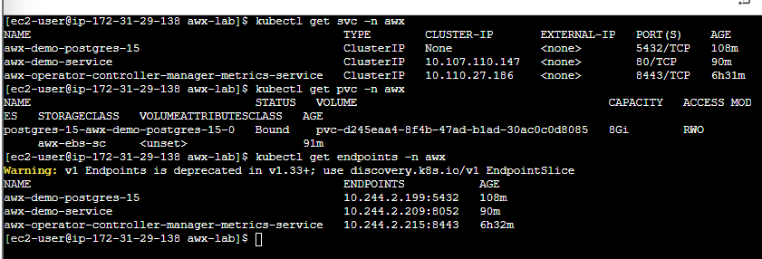
Step 8: Retrieve the AWX admin password
Run this command on your EC2 terminal:
kubectl get secret awx-demo-admin-password -n awx \
-o jsonpath='{.data.password}' | base64 --decode
echo
Save the password securely. Do not share it here.
UuEBq9g0MrjMVc0e19mWx8yipqszO5md
Step 9: Start port forwarding
Run:
kubectl port-forward -n awx svc/awx-demo-service 8080:80
Keep this terminal open. You should see a message indicating that port forwarding is active.
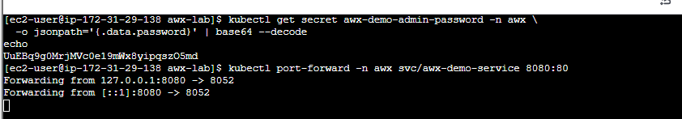

Step 10: Open the AWX dashboard
Your port-forward command is running on the EC2 instance. Since 127.0.0.1 refers to the machine where the command runs, you need an SSH tunnel to access it from your Windows computer.
On your Windows PowerShell, open a new terminal and run:
ssh -i "C:\path\to\your-key.pem" -L 8080:127.0.0.1:8080 ec2-user@YOUR_EC2_PUBLIC_IP
Replace:
- C:\path\to\your-key.pem with your actual EC2 key file path.
- YOUR_EC2_PUBLIC_IP with your EC2 instance's public IP address.
Keep both terminals open.
Then open this URL in your Windows browser:
http://localhost:8080
Step 11: Sign in
Username: admin
Password: Use the password retrieved in Step 8.
Security note: Your password was exposed in the chat. Once you successfully log in, change it if possible and avoid sharing it again.
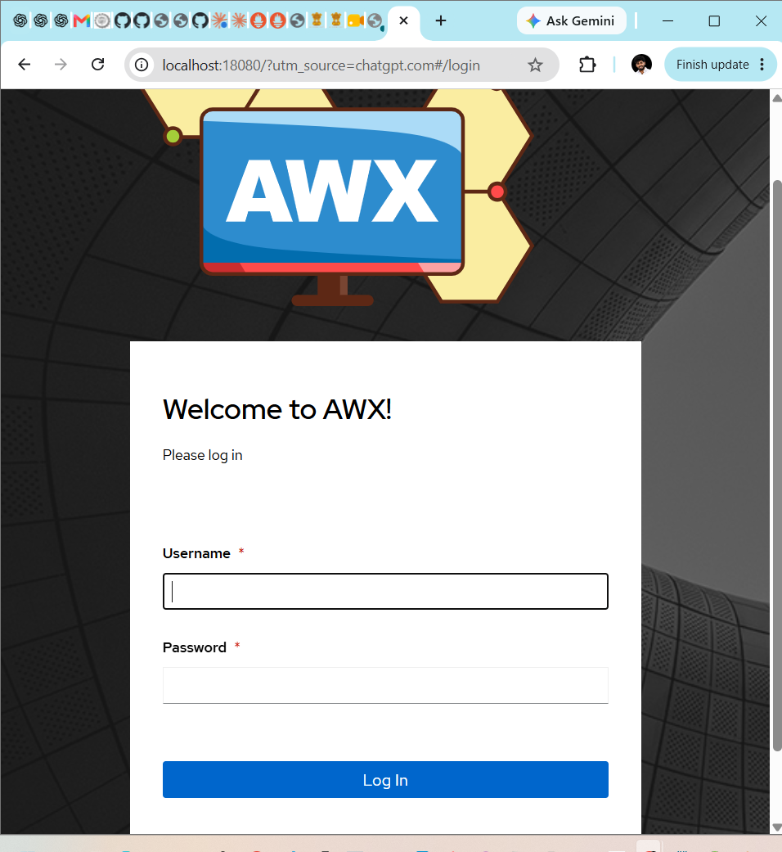
Step 12: Log in to AWX
Enter these credentials on the page shown in your screenshot:
- Username: admin
- Password: The password you retrieved earlier using the Kubernetes Secret command.
Click Log In.
Step 13: Verify the dashboard
After logging in, confirm that the AWX dashboard loads successfully.
You can then start configuring:
- Organizations
- Credentials
- Projects (Git repositories)
- Inventories
- Job Templates
- Ansible Playbooks and job execution
Complete the login first and tell me whether it succeeds.
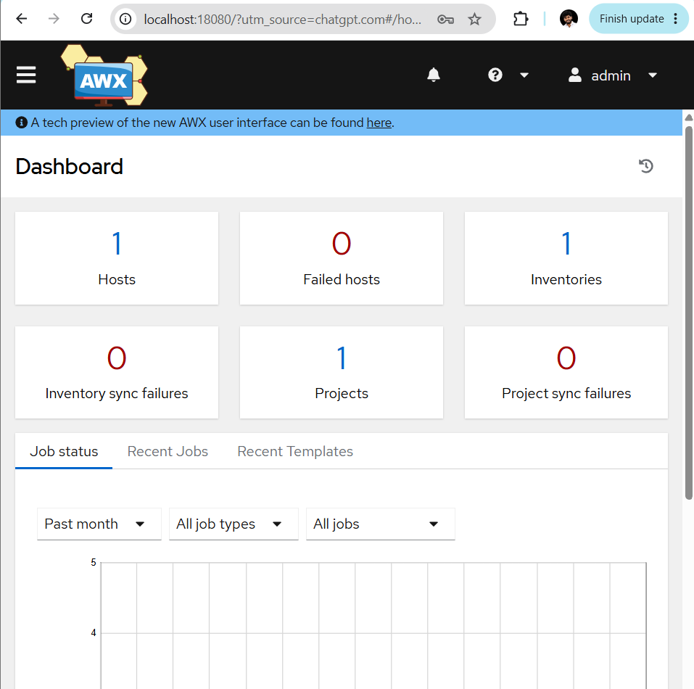

Step 14: Verify the existing AWX Project
- In the AWX dashboard, click the ☰ menu in the top-left corner.
- Under Resources, click Projects.
- Open your existing project.
- Check its Status and Source Control URL.
A successful project sync should show Successful.
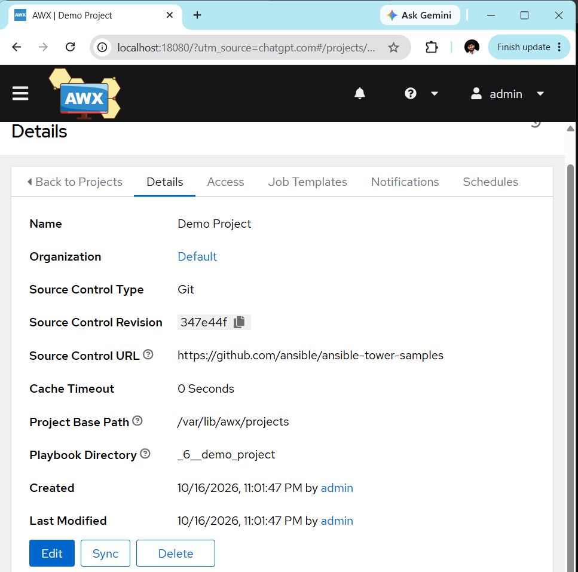
Step 15: Verify the Inventory
After checking Step 14:
- Open the ☰ menu.
- Under Resources, click Inventories.
- Open your existing inventory.
- Check that your inventory contains the expected host.
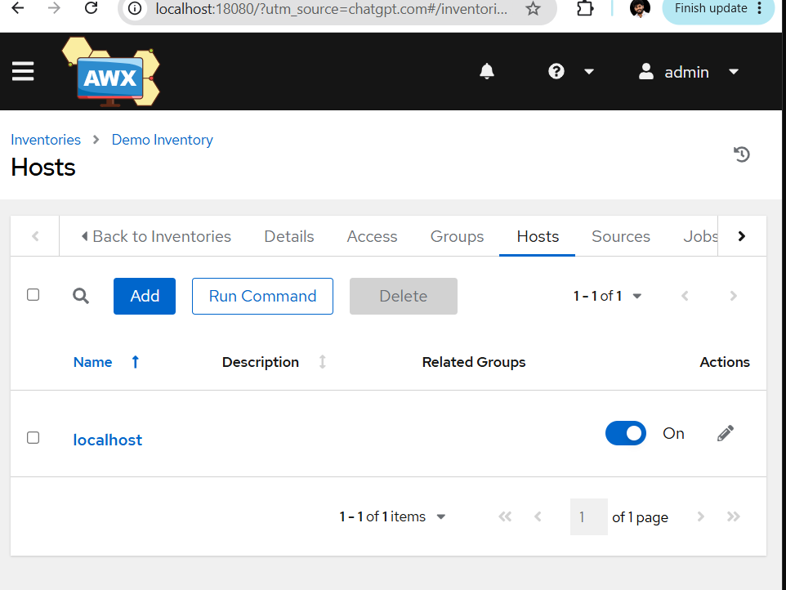
Step 16: Verify Machine Credentials
- Open the ☰ menu.
- Go to Resources → Credentials.
- Check whether you have a Machine credential for connecting to your Ansible-managed hosts.
Do not create duplicate projects, inventories, or credentials if they already exist.
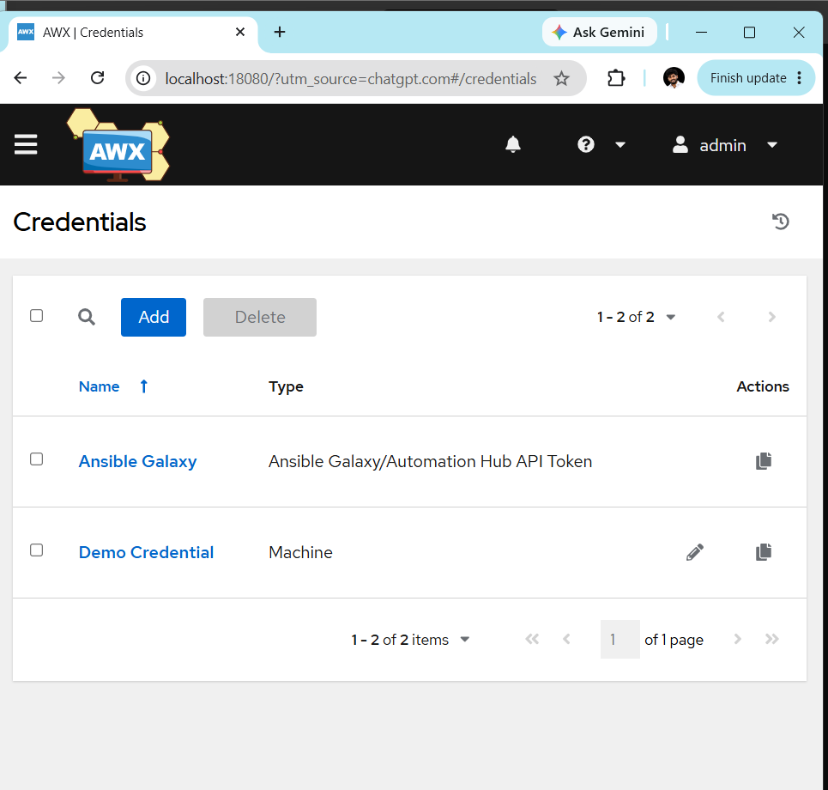

Step 17: Verify the Machine credential
- Click Demo Credential.
- Check the credential details, especially:
  - Credential Type: Machine
  - Username: the SSH user for your managed EC2 hosts (for example, ubuntu or ec2-user)
  - SSH Private Key: configured if your hosts require key-based authentication
- Do not expose or share the private key or password.
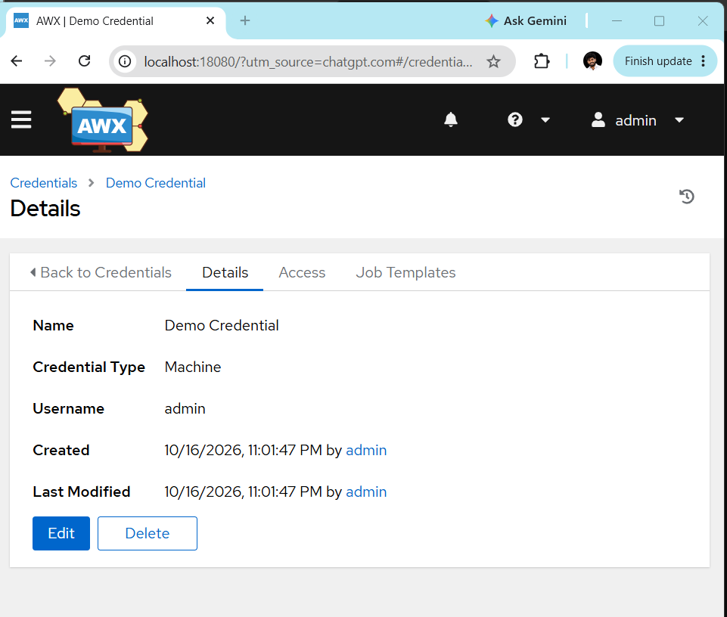
Step 18: Verify your existing AWX Project.
Step 18.1 — Open Projects
- In AWX, click the ☰ menu in the top-left corner.
- Under Resources, select Projects.
- Open your existing project.
Step 18.2 — Check the project status
Verify these details:
- SCM Type: Git
- SCM URL: Your Git repository URL
- Status: Successful, if the project has synced successfully
Do not create another project yet.
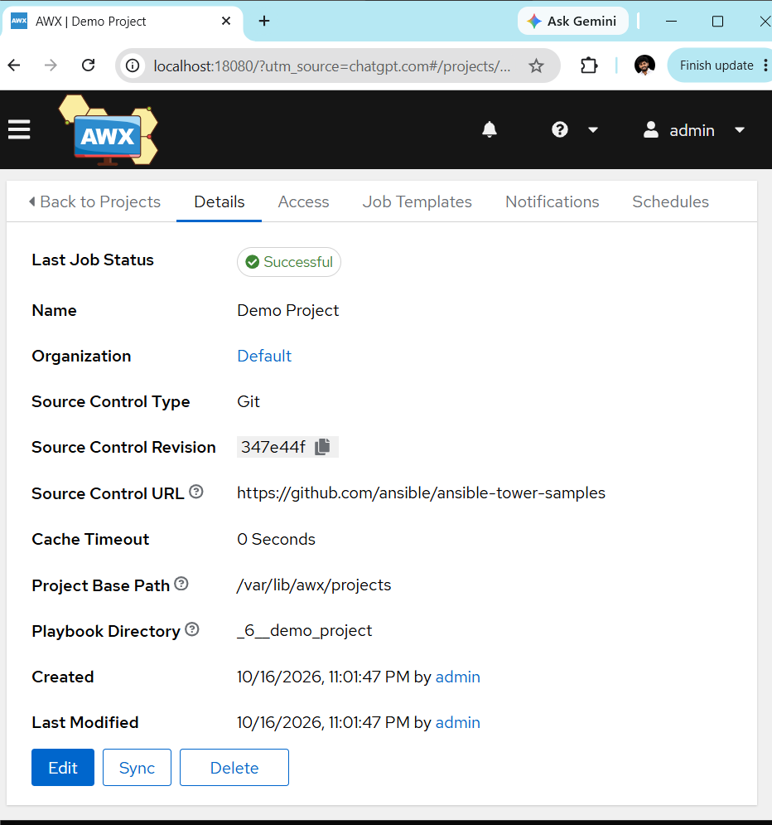
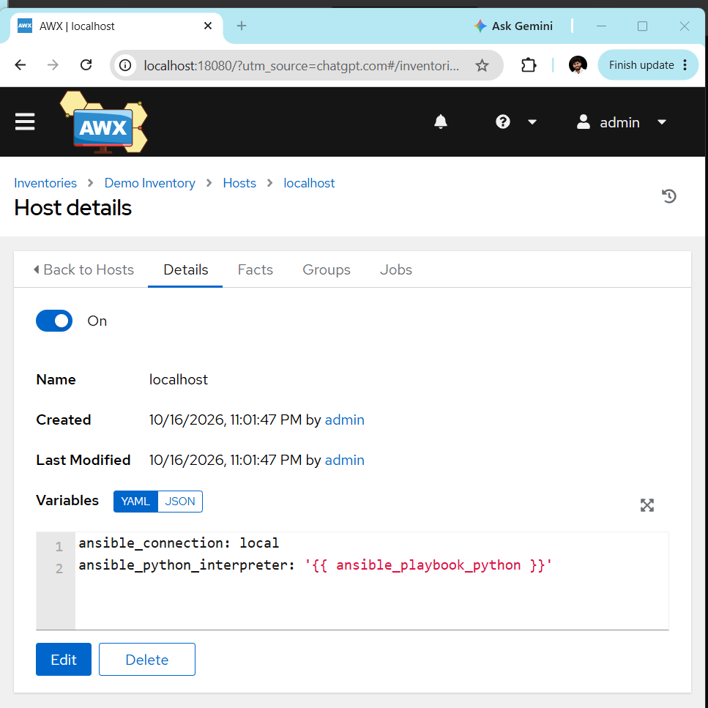

Step 19 — Open the Inventories page
- Click the ☰ menu in the top-left corner.
- Select Resources → Inventories.
- Click your existing inventory.
- Open the Hosts tab.
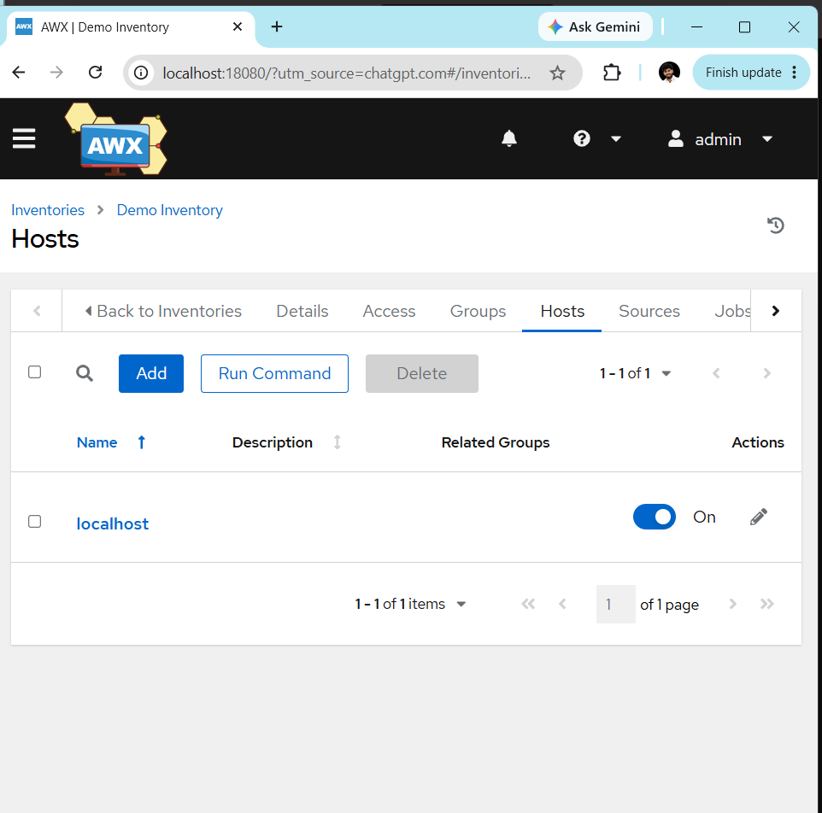
Step 20: Check the host configuration
- Click localhost in the Hosts list.
- Open its details and click Edit.
- Check the Variables field for the host connection settings.
For a local-only test, localhost may be appropriate. To manage your EC2 worker nodes, the inventory must instead contain their reachable IP addresses or hostnames, with the correct SSH connection settings.
Step 21: Verify your existing AWX configuration
Your AWX dashboard is already accessible at http://localhost:18080.
- Return to the AWX dashboard.
- Open Resources → Templates.
- Check whether a Job Template already exists.
If a template exists, do not create another one. Send me a screenshot of the Templates page, and I'll guide you through testing the existing configuration.
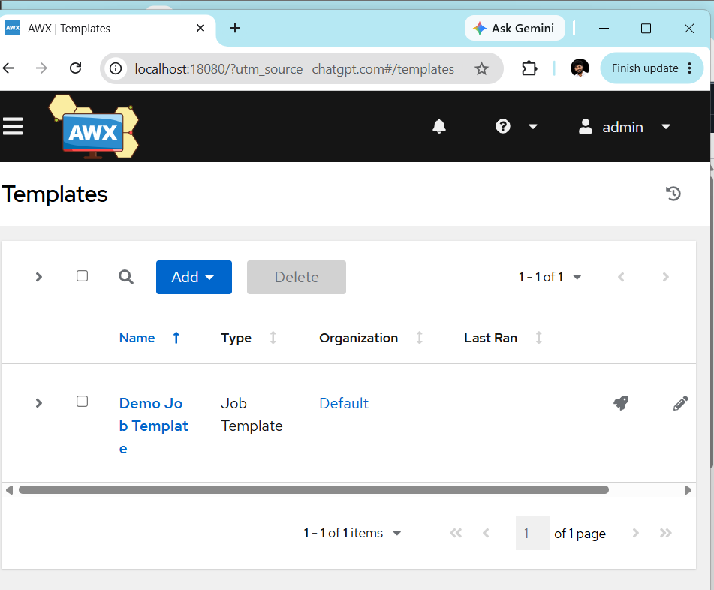
Step 22 — Run the existing Job Template
- In AWX, open Resources → Templates.
- Click Demo Job Template.
- Verify the Inventory, Project, Playbook, and Credentials are correctly selected.
- Click Save only if you made changes.
- Click the Launch (🚀) icon beside the template.
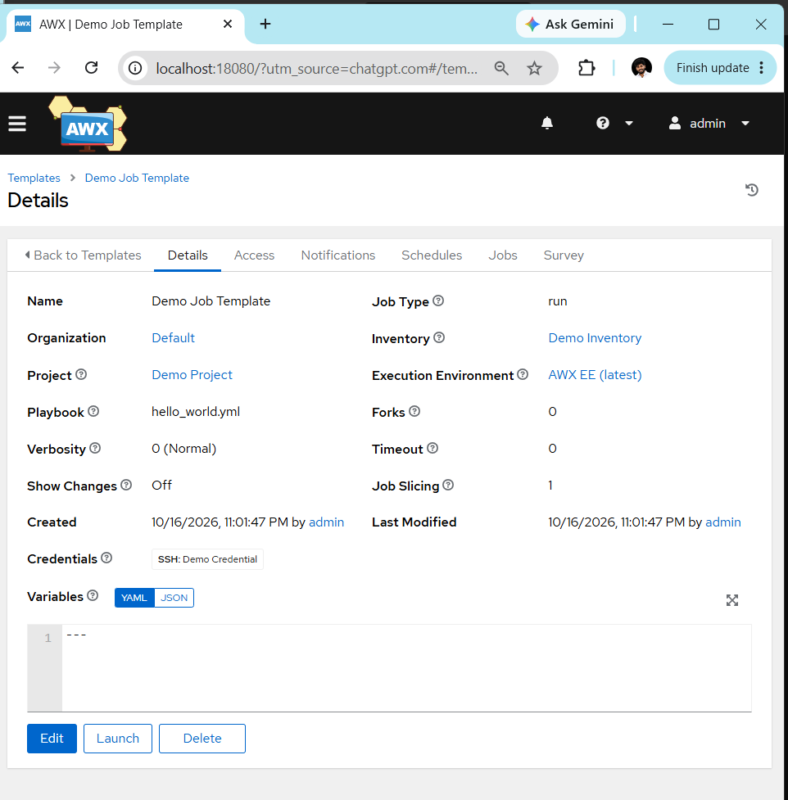
Step 23 — Verify the job
- Open Views → Jobs or click the launched job.
- Wait for execution to finish.
- Check the final status.
- Successful — the AWX test is complete.
- Failed — inspect the job output to identify the issue.
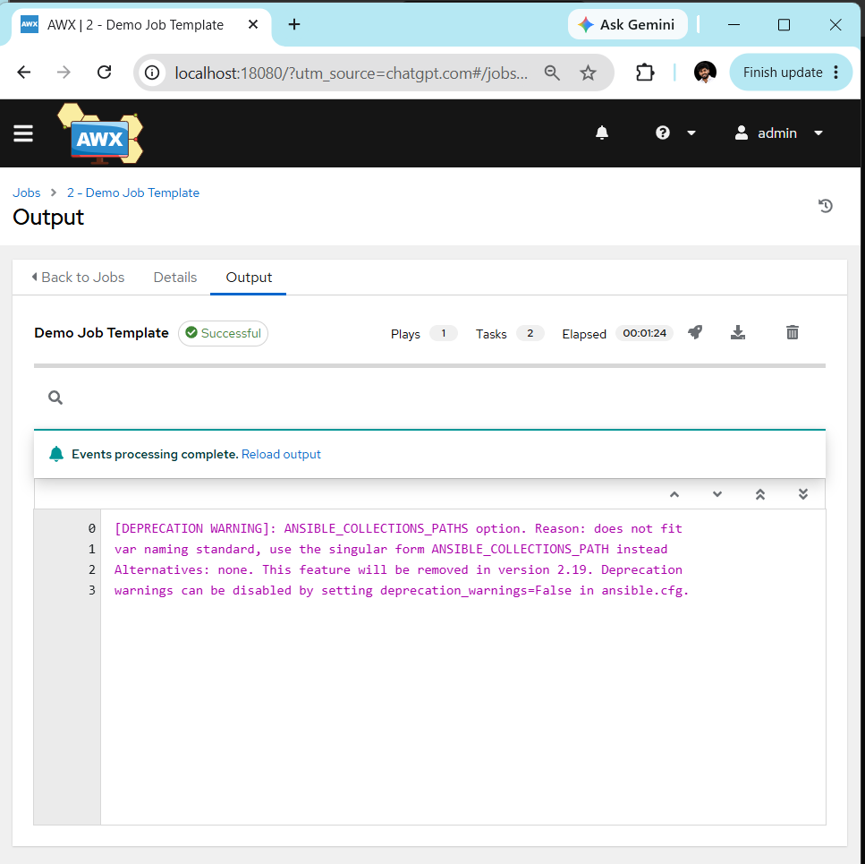
Step 24 — Final verification
Confirm that the job completed successfully and review its output.
